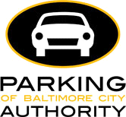

ADVISORY BOARD AGENDA
9.16.2021

September Agenda

- Call to Order
- Review/approval of meeting minutes from 5.12.21
- Objectives & Expectations
- Elections of Officers (Chair, Vice Chair, Secretary)
- PABC brief operations updates:
  - RPP's 2021/2022 Permit Renewals
  - Mailing permits & Print-at-home temp permits
  - Meters
  - Valet
- Update on Virtual Permit Parking in Riverside & Ridgley's Delight
- Open Discussion on Virtual Permit Parking
  - Where we are now
  - Upcoming RFP
  - Upcoming invitation to participate in testing
- Open comments/thoughts as time allows
- Adjourn

Meeting via Teams:
- https://bit.ly/3zfGzIe

