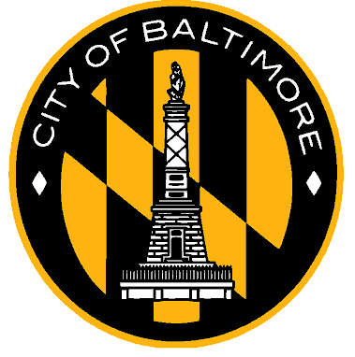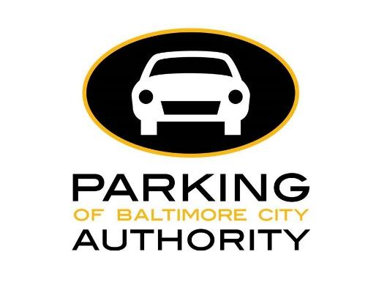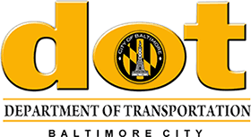

FOR IMMEDIATE RELEASE

May 13, 2021

Press Contacts:
Tiffany James
Parking Authority of Baltimore City
Tiffany.james@bcparking.com
410-227-7517

German Vigil, Kathy Dominick
Baltimore City Department of Transportation
(410) 361-9296

Baltimore City Replaces On-Street Pay and Display Parking Meters
with Pay by License Plate Meters
Parkers No Longer Need to Display Receipt on Dash

BALTIMORE, MD — Mayor Brandon Scott along with the Parking Authority of Baltimore City and the Department of Transportation announced today that the last of the City’s on-street Pay and Display parking meters have been replaced with new Pay by License Plate parking meters.
Sometimes called EZ Park Meters, the old pay and display parking meters, which were installed beginning in 2004, required parkers to display a printed receipt on their dashboard to verify that they had paid for parking.
The new pay by license plate parking meters, which were installed beginning in 2019, do not require motorists to return to their vehicle and place the receipt on their dash. Instead, parkers enter the vehicle’s license plate number into the parking meter before paying for the time they wish to park. Parking enforcement agents, who are Department of Transportation employees, download real-time data from the parking meters into handheld devices that show which vehicles have paid for parking.
A total of 830 pay by plate meters have been installed. They still accept coins, credit, and debit cards. Parking duration limits and hours of operation have not changed.

“The first thing you do at the meter is enter your license plate number, so we recommend writing it down or taking a photo of your license plate number before you go to the parking meter,” Parking Authority Executive Director Pete Little said, “After you’ve used the meter, you can walk directly to your destination.”

Parking enforcement officers have been pleased with the new handheld devices provided by G-Techna. This new technology quickly provides parking enforcement with the data they need —which vehicles have paid for parking, within minutes. This means officers no longer have to search the vehicle’s dash for a receipt.

“We are excited to be using this new technology which brings parking enforcement up to date with modern equipment,” said Department of Transportation Director Steve Sharkey.

Parkers who move their cars to another block are required to pay for another session at the parking meter on that block and must follow all posted parking restrictions.

Should parkers need more information on how to use the new parking meters, please go to the Parking Authority website at https://parking.baltimorecity.gov/parking-meters.

About the Parking Authority of Baltimore City

Parking Authority of Baltimore City (PABC) is a quasi-governmental agency of Baltimore City and a registered 501c3 with a mission to find, or create, and implement parking solutions for Baltimore City, and to be the resource on all things "parking" in Baltimore. PABC oversees the management of 14 parking garages, numerous lots, over 800 parking meters, over 1,500 reserved residential handicap parking spaces, and 48 residential permit parking areas.

###

