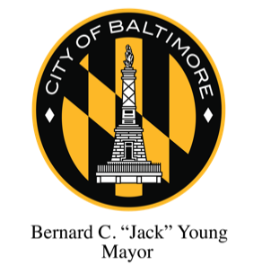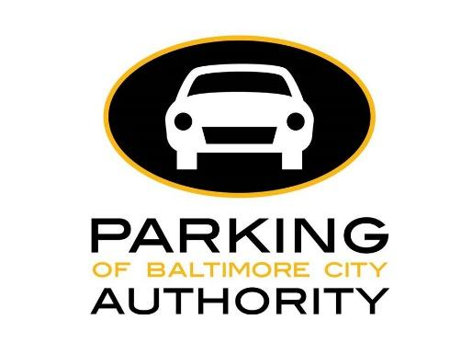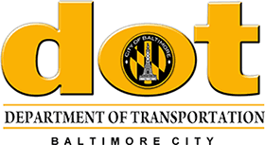

FOR IMMEDIATE RELEASE

Tuesday, July 7, 2020

Press Contacts:
Tiffany James
Parking Authority of Baltimore City
Tiffany.james@bcparking.com
410-227-7517

German Vigil, Kathy Dominick
Baltimore City Department of Transportation
(410) 361-9296

Baltimore City to Resume Parking Meter Enforcement
Enforcement Will Begin Monday, July 13, 2020

BALTIMORE, MD — Mayor Bernard C. “Jack” Young along with the Department of Transportation and the Parking Authority of Baltimore City announced today that the enforcement of parking meters throughout the city will resume beginning on Monday, July 13, 2020.
The City of Baltimore began Phase Two of its reopening plan on June 19, 2020, which included indoor dining at 50% capacity. Parking meter enforcement supports the turnover of on-street parking spaces available to patrons of local shops, restaurants, businesses, and attractions. All parking meters in the downtown area and throughout the city will be in operation starting July 13th and people should follow the posted time limits and hours of operation. Motorists should not park at any meters which are bagged or inoperable.
Nearly 300 older pay and display parking meters have been replaced since late 2019, many during the pandemic which forced restaurants and retail businesses to close. These new parking meters do not require drivers to return to their vehicle to place a receipt on the dash. Instead, these electronic kiosks use the vehicle’s license plate number, which is entered at the beginning of the transaction. City parking meters accept cash (coins), credit and debit cards.

“While we continue to work to combat the spread of COVID-19, I am pleased that Baltimore City has successfully shifted into its second phase of reopening businesses and services,” Mayor Young said. “As people continue to move around and be outside, it is important as we continue through Phase Two that we return many of our services to help our economy recover.”

In addition to restoring parking meter enforcement, the Department of Transportation continues citywide enforcement efforts with modified operations. We encourage the general public to visit our website for an updated list of modified services. Transportation Enforcement Officers will continue to focus on citing immediate safety and pedestrian issues.

“This revised approach to metered parking enforcement supports access to local businesses that are resuming operations to serve city residents,” said Department of Transportation Director Steve Sharkey. “As businesses begin to return to normal, we recognize how essential parking is to area residents and business patrons.”

About the Parking Authority of Baltimore City

Parking Authority of Baltimore City (PABC) is a quasi-governmental agency of Baltimore City and a registered 501c3 with a mission to find, or create, and implement parking solutions for Baltimore City, and to be the resource on all things "parking" in Baltimore. PABC oversees the management of 14 parking garages, numerous lots, over 800 EZ Park Meters, over 1,500 reserved residential handicap parking spaces, and 48 residential permit parking areas.

###

