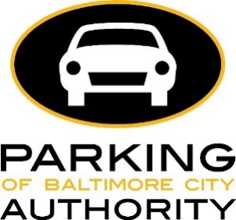

Beginning February 1, 2018, the Parking Authority of Baltimore City will again adjust parking meter rates in the Central Business District (CBD) using Demand-Based Parking Meter Rate Setting. Using occupancy data collected every six months, we are adjusting rates slowly and incrementally (no more than 25₵ every six months) to produce one or two available parking spaces on each block face (15-25% availability; or 75-85% occupancy).
Data collected between 10/17/17 and 11/16/17 showed that the following rate adjustments should be made in the CBD:
- On 36% of blocks, the rate should go down $0.25
  - Average occupancy rates on these blocks were below 75% (too low)
- On 43% of blocks, the rate should go up $0.25
  - Average occupancy rates on these blocks were above 85% (too high)
- On 21% of blocks, the rate should not change
  - Average occupancy rates on these blocks were between 75% and 85% (just right)
Current rate information and maps are available on our website: baltimoreparkingmeters.com.
Demand-Based Parking Meter Rate Setting was first implemented in July 2017. At that time all parking meters in the CBD were $2.00.
“It is still extremely hard to find parking on some blocks in the Central Business District. The rates on these blocks still need to be adjusted to meet our goal of one to two available parking spaces. But, there are also many blocks where demand is low, and we will encourage drivers to park on these blocks by lowering the rate.” –Peter E. Little, Executive Director, Parking Authority of Baltimore City.

