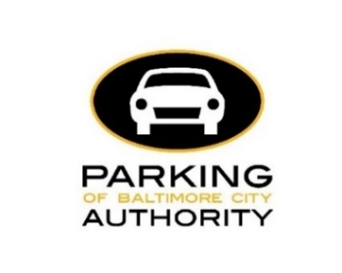
MEMORANDUM

To: PABC Board of Directors

From: Francis Burnszynski, Parking Planning Manager

Date: December 1, 2022

RE: Mt. Vernon Demand-Based Parking Meter Rate Setting Recommendations Round 2

Approval Request
PABC staff request PABC Board of Directors’ approval of the following recommendation:
- Adjustments of on-street parking meter rates in the Mt. Vernon area (defined here as the area bounded by Mt. Royal Avenue on the north; Franklin Street on the south; Eutaw Street, Martin Luther King Jr. Boulevard and Howard Street on the west; and Guilford Avenue on the east) as outlined in this memo.
  - Parking meter rates on any block may be adjusted up or down only in 25¢/hour increments and no more than once every 6 months.
    - If occupancy is higher than 85% in a particular block, then the parking meter rate may be adjusted upward incrementally and slowly until occupancy hits 85%.
    - If occupancy is lower than 75% in a particular block, then the parking meter rate may be adjusted downward incrementally and slowly until occupancy hits 75%.
    - If occupancy is between 75% and 85%, then the parking meter rate will not be adjusted.
  - Each parking meter rate adjustment within Mt. Vernon will be reviewed and approved by the Board of Directors of the Parking Authority prior to the implementation.
  - Notice of each parking meter rate adjustment within Mt. Vernon will be sent to the District 11 and 12 Council Members at least one month prior to implementation.
- Adjustment of parking meter in-effect times in Mt. Vernon as outlined in this memo.
- Commencement of metering 200 E Mt Royal N/S and 800 N Calvert E/S as outlined in this memo.

Background
The goal of parking meters is to create on-street parking availability, so that customers of stores, restaurants, and attractions can easily find a parking space near their destination. This goal is achieved through setting parking meters at the lowest rate that result in one or two available parking spaces on each block face (about 15% - 25% availability, or about 75% - 85% utilization). When meter rates are too low, demand for parking goes up and a block may be overparked. When meter rates are too high, fewer drivers are willing to pay the rate and a block may be underutilized. Effective metering that results in one or two available spaces per block reduces the number of cars circling to find parking. That means drivers benefit from greater convenience, and the whole City benefits from reduced congestion, lower emissions, and reduced fossil fuel usage. Currently, the PABC is using the demand-based pricing model in the Central Business District, Harbor East, Federal Hill, Fells Point, and Mt. Vernon.
Determining the lowest meter rates that result in one or two available spaces is an iterative process based on collecting and analyzing data and altering rates incrementally. To determine the correct meter rates, the Parking Authority of Baltimore City (PABC) collects and analyzes parking utilization data no more than twice per year in Mt. Vernon. Rates are adjusted in $0.25 increments after each parking demand study if the blockface is not in the desired range. If on-street parking occupancy is higher than 85% on a block face, the rate generally increases. If on-street parking occupancy is lower than 75% on a block face, the rate generally decreases. If on-street parking occupancy is between 75% and 85% on a block face, the rate generally is maintained.
Data from Round 2 of the PABC’s Mt. Vernon demand-based parking meter rate adjustments study was collected in October and November of 2022. The PABC first determined the parking capacity of each block face included in the study area. Then the number of cars parked was counted at different times of the day and evening, for both weekdays and Saturdays. The data was compiled and analyzed to determine a utilization rate (average percentage of the block’s capacity that is parked).
Parking behaviors have likely been impacted because of COVID-19. The PABC will continue to observe changes in parking utilization during future data collection rounds.
This study collected parking data on some of the adjacent Residential Permit Parking (RPP) regulated streets in Mt. Vernon as a point of reference and is not meant to be an RPP study. It will provide a baseline to understand potential changes to demand that might occur when demand-based meter pricing rates are adjusted each round.

Study Findings
For the second round, the analysis indicates that during all days and times, an average of 23% of blockfaces in Mt. Vernon are over-parked (with fewer than one free space available), while 42% are under-parked (with more than two spaces available). Compared to the first round, the number of blockfaces that will maintain at their current rate nearly tripled.

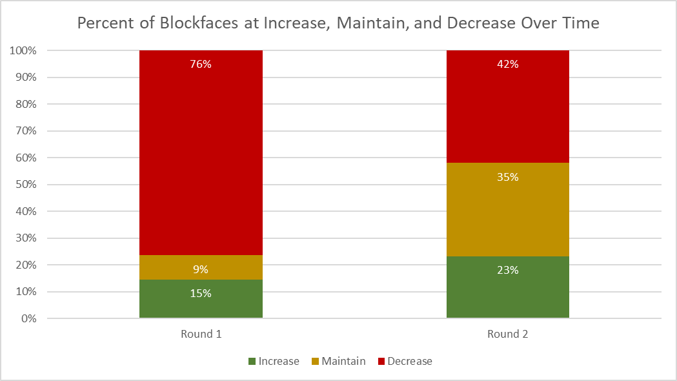

Recommendations

New Meter Rates
The first recommendation of the study is to implement new meter rates based on the data collected and analyzed. Of the 112 blockfaces studied with meters, 26 blockfaces (23%) rates will increase by $0.25, 39 blockfaces (35%) rates will maintain their current price, and 47 blockfaces (42%) rates will decrease by $0.25. There are 86 blockfaces (77%) overall that will either maintain or decrease their current rates.
New Meter Rates
Rate per Hour | # of Block Faces | % of Total
$2.50 | 2 | 2%
$2.25 | 1 | 1%
$2.00 | 6 | 5%
$1.75 | 7 | 6%
$1.50 | 40 | 38%
$1.25 | 7 | 6%
$1.00 | 9 | 8%
$0.75 | 9 | 8%
$0.50 | 31 | 27%

Increase: 26 block faces (23%)
Maintain: 39 block faces (35%)
Decrease: 47 block faces (42%)

For Round 2, there will be 9 meter rates throughout Mt. Vernon: $2.50, $2.25, $2.00, $1.75, $1.50, $1.25, $1.00, $0.75 and $0.50. The table above shows the number of block faces with each rate. Nine blockfaces have had increases in both rounds of the study. In this round, the data recommends that hourly rates for 12 blockfaces should fall below $0.50. When parking utilization remains low consistently and reaches $0.50 per hour, it is worthwhile to consider removing parking meters or to extend the amount of time that a parking session may occur to a longer duration. In this case, because of potential changes in parking behavior due to COVID-19, and because this is only the second round of the study, our recommendation is to wait until a later date once the pandemic has less influence on parking and travel behavior and the area is studied again.

Extending Meter-in-Effect Times
The second recommendation of the study is to extend the hours of metering of several high parking demand blockfaces in Mt. Vernon. The PABC recommends extending the meter-in-effect times until 8 p.m. based on uses – i.e., the presence of businesses that are open and generating high parking demand – in areas where there is a large discrepancy between daytime and evening parking demand or where parking demand is consistently high in the daytime and evening. The blockfaces we are recommending have extended meter-in-effect times include the S/S of 200 W Centre, the unit block of W Biddle, the 100 block of W Mt Royal, the 100/1200 block of W Mt Royal, and the 800 block of N Charles. The table below identifies the selected blockfaces with meter-in-effect times that should be extended based on adjacent uses and parking activity.

Blockfaces to Extend Meter-in-Effect Time To 8PM
Block | Street | Side | Current Hours | New Hours
200 | W Centre | SS | Mon-Sat, 8AM-6PM | Mon-Sat, 8AM-8PM
Unit | W Biddle | NS | Mon-Sat, 8AM-6PM | Mon-Sat, 8AM-8PM
100 | W Mt Royal | NS | Mon-Sat, 8AM-6PM | Mon-Sat, 8AM-8PM
100 | W Mt Royal | SS | 9a-6p MF 8a-6p SA | 9a-8p MF 8a-8p SA
100/1200 | W Mt Royal | SS | Mon-Sat, 8AM-6PM | Mon-Sat, 8AM-8PM
800 | N Charles | ES | 8a-4p M-F, 8a-6p on Sat | 8a-4p, 6p-8p M-F, 8a-8p on Sat
800 | N Charles | WS | Mon-Sat, 8AM-6PM | Mon-Sat, 8AM-8PM

Commencement of Metering
The third recommendation of the study is to add metering to two blockfaces in Mt. Vernon. The blockfaces of 200 E Mt Royal N/S and 800 N Calvert E/S were mentioned in the round 1 study as blockfaces to potentially meter. The data from round 2 indicate high parking utilization on both blockfaces once again, so the PABC will move forward with advising the City Councilmember from District 12 that we will install meters at these locations and then installing meters.

Target Utilization

The first round study found that 10 blockfaces (9%) were at target utilization. The second study showed 39 blockfaces (35%) reaching target utilization. We anticipate that the percentage of blockfaces achieving the target parking utilization will increase with future reviews. This would signify improvement in parking availability as well as distribute the parking utilization more evenly throughout Mt. Vernon. The following pages include a spreadsheet with new meter rates along with maps which depict the recommendations and the new meter rates.
