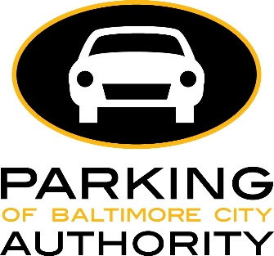
Residential Permit Parking (RPP)
Notarized Letter for Authorized Vehicle Use
PLEASE PRINT CLEARLY
NOTE: If you share the same last name with the vehicle owner, this form is not required.
CURRENT RESIDENCY INFORMATION:
FULL NAME (PRINTED): _______________________________________________________________
ADDRESS: __________________________________________________ APT/UNIT #:______________
CITY/STATE/ ZIP CODE: ________________________________________________________________
SIGNATURE__________________________________________________ DATE: __________________
I do hereby attest and affirm that the information enclosed in this letter is truthful, current and accurate to the best of my knowledge and the legal owner of this vehicle is signing this authorization.
TO BE FILLED OUT BY VEHICLE OWNER:
I _____________________________________ do hereby attest that the above signed person has authorization for use of my vehicle.

VEHICLE STATE: __________________ PLATE #_______________________ YEAR: __________________
MAKE:__________________ MODEL:_____________ VIN ______________________________________

SIGNATURE OF VEHICLE OWNER ___________________________________ DATE__________________

NOTARY STAMP AND INFORMATION:
Sworn to and subscribed before me:
This_______ day of_________ yr __________
SIGNATURE: ___________________________
DATE: ________________________________

